ABU LIBRARY COMPLEX BULLETIN
MONTHLY BULLETIN VOLUME: Vol. 3 No. 1 WEDBESDAY, 4TH MAR. 2015

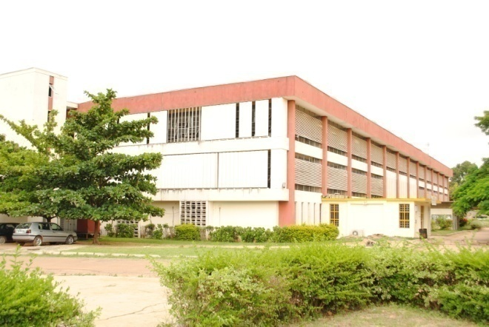
GETTING ACQUINTED WITH THE ABU LIBRARY COMPLEX SERIES 2
This is the 2nd in the series “Getting acquainted with ABU Library Complex.” Our focus is on Information and Communication Technology (ICT) Division, Kashim Ibrahim Library.
INFORMATION & COMMUNICATION TECHNOLOGY DIVISION
In order to fulfill its mandate of providing access to information of all types in a wide variety of format, the ICT Division was established to ensure the overall management of electronic resources and services in the library. The Division came into being in 2010 and is made up of five (5) units which comprise of Databases/CDROM Search, Digitization, Internet Training, Technical and MTN net library. Since its inception the Division has made remarkable progress in the area of IT and efficient service delivery in the library complex. The progress can be attributed to the sacrifices of the diligent staff in the Division. Major strides were recorded in the following areas: training of library staff, faculty staff, postgraduate students; increase in the use of MTN net library by students; supervision of satellite libraries in the development of ICT; and increase in the volume of digitized theses and dissertations.
About the Head of ICT Division.
Mal. Aliyu Abdulkadir was born on the 15th of June 1974 and hails from Lere in Kaduna State. He obtained the Nigerian Certificate in Education (NCE) in 1996 and his first degree in Library and Information Science in 2001 with Second Class Upper from the Department of Library and

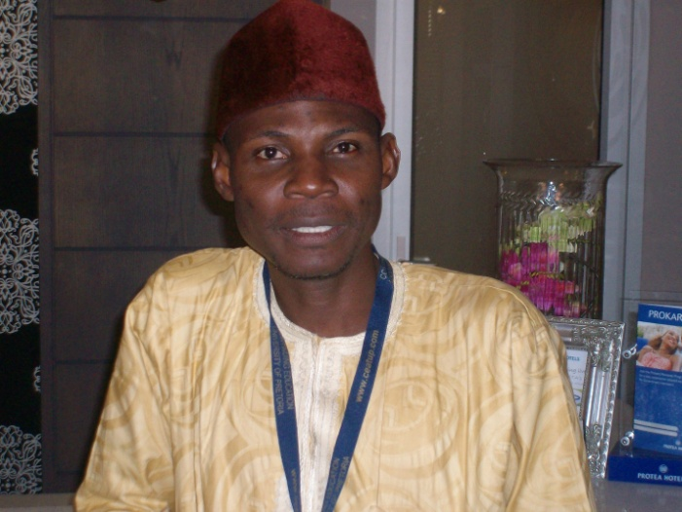Mal. ABDULKADIR ALIYU
NCE, BLS, MLS, CLN
Information Science, Ahmadu Bello University (ABU), Zaria. In 2011 he obtained a Masters in Library Science and is presently pursuing his PhD in the same department. Also to his credit are a number of Professional Certificates in Information and Communication Technology obtained both locally and internationally. He joined the services of Ahmadu Bello University (ABU), Zaria in 2005 and has worked in different libraries and sections before been transferred to ICT division in Kashim Ibrahim Library. Aliyu has attended many local and international workshops, seminars and conferences some of which he facilitated. Aliyu is a chartered librarian and an active member of Nigerian Library Association. He holds the position of Assistant Secretary of the Kaduna State Chapter. His hobbies are reading, travelling and listening to music.

UDERSTANING DATABASES - HINARI, AGORA, OARE AND TEEAL
(Available at KIL)
HINARI is the Health InterNetwork Access to Research Initiative. Launched in 2001 with close to 2500 public institutions already registered for access in 113 developing countries, HINARI is managed by the World Health Organization in partnership with Yale University Library. Around 90 publishers contribute their journals to HINARI. HINARI provides access to over 3400 peer-reviewed journals covering medicine, nursing and related health and social sciences. It also includes many databases, indexes and reference books, as well as journals in several languages.
Access to information is an essential element in strengthening local medical, agricultural and natural resource management practices, and empowering local experts to find solutions to local health, environmental, social, economic, and food issues. Scientists, researchers, academics, policy makers and medical practitioners in developing countries institutions now have access to advanced and up-to-date peer-reviewed research literature.

There are now over 3000 public institutions registered to access HINARI, AGORA and OARE in more than 100 countries in Africa, Latin America, Asia and Europe. The programs are closely tied to the United Nations’ Millennium Development Goals. These initiatives represent a truly global public private partnership for development, providing essential information for life to those who need it most.
Benefits - *Access to thousands of peer-reviewed international scientific journals online. *Specialist databases, indexes, and reference books also available. *Resources available in several languages. *Access is available free to the researcher. *Users can link to and from abstracting and indexing databases. *Full-text articles can be downloaded for saving, printing or reading on screen. *Many articles available online before they are published in print. *Users can search by keyword, subject, author, or language. *Training and promotional resources and support available on request

TEEAL: The Essential Electronic Agricultural Library (TEEAL), is a full-text and searchable database of articles of international, peer-reviewed journals spanning a wide variety of subjects. TEEAL has more than 325 high-quality research journals in agriculture and the related sciences. Beginning with the 2012 update of TEEAL, research material from the Bill & Melinda Gates Foundation is included in the TEEAL collection.
Subject Coverage
Agricultural Engineering/Agriculture/Animal Science/Veterinary medicine/Biotechnology/ Applied microbiology/Chemistry/Biochemistry/ Biophysics/Economics/Social Science/ Development/Entomology/Pest Control/ Environment/Ecology/Natural Resources/Fisheries/ Aquatic Science/Food Science/Nutrition/Forestry/ Human/Medicine/ Physiology/Plant Science/Soil Science
Benefits - *Current agricultural research. *Access to hundreds of essential agricultural Journals. *No internet connection required. *Download full-text articles and abstracts. *Read, save, and print your Search
TEEAL and AGORA databases form an important part of the electronic resources at Ahmadu Bello University, Zaria primarily targeted to meeting the information needs of the researchers at the Faculty of Agriculture and the Institute for Agricultural Research. To that end our institution has received a new redesigned TEEAL set, which is an offline full-text and searchable database of high-quality research journals in agriculture and related sciences spanning from 1993 – 2012.
Access and further information is available at www.abu.edu.ng/library. Click Service on the Library home page. Follow the hyperlink Database and References. Next, click on Specialised Databases where you will find.
Another milestone was the MOU signed between Information Training and Outreach Centre for Africa (ITOCA) and A.B.U Zaria to partner in a leadership program. The MOU will afford the library to serve as a centre of excellence for training and outreach activities.
STAFF OF THE MONTH
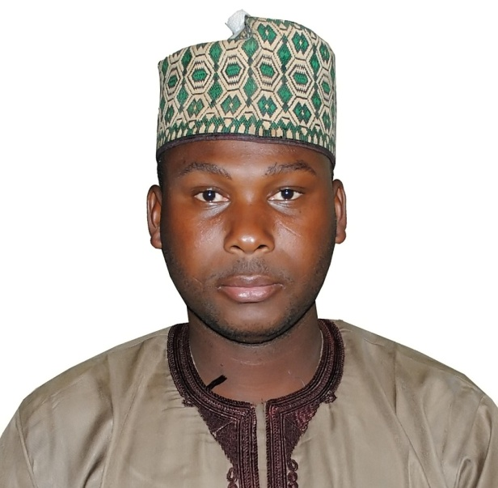
Rufa’i Aliyu (Turakin Sarkin Bakan Zazzau) is a staff of ICT Division, Kashim Ibrahim Library. He is acknowledged for his punctuality and diligence at work.
Media & Public Relations Division, KIL – Here to serve you www.abu.edu.ng/library

